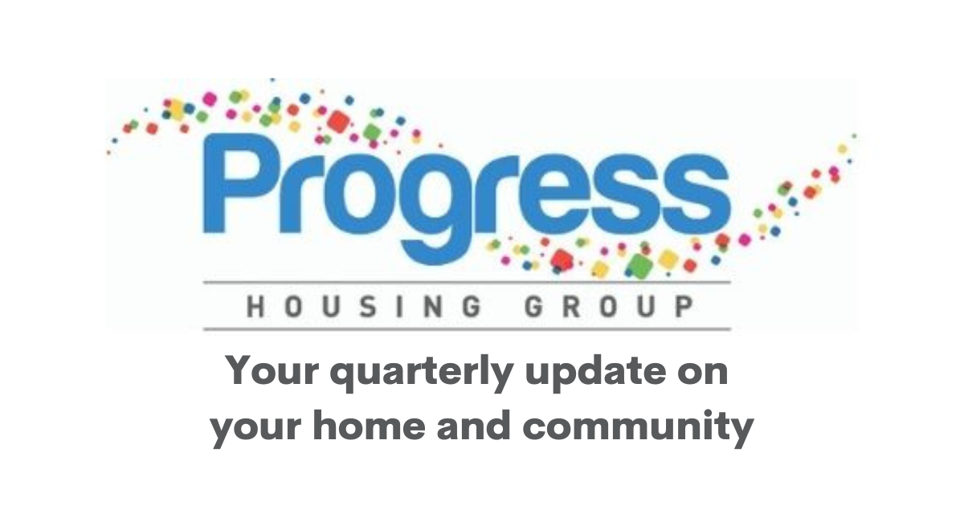

Hello
Welcome to your quarterly email newsletter, where we share all the latest news on your home, services and local communities.

We put our tenants and customers at the heart of everything we do.
To do that well, we need your help to share your thoughts on our services and shape what we do.

Have your say

Consultations
The government has launched three consultations to improve social housing for tenants.

If you would like to find out more about these consultations and have your say, join us for an information and discussion session at one of our independent living schemes in South Ribble, Lancashire, on Tuesday 19 August, from 10.30am until 3pm. We will confirm the scheme nearer the time. We will reimburse any travel costs and lunch will be provided.

If you would like to find out more or would like to express an interest, please contact the Customer Voice Team at community@progressgroup.org.uk, or call Diane on 07870 900991.

The three government consultations are:
- Social Rent convergence
- Decent Homes Standard
- Improving the Energy Efficiency of Socially Rented Homes in England

Tenant Voice

- The next Tenants’ Forum meeting is Monday 4 August 2025 – Sumner House, King Street, Leyland, 1.30pm – 3.30pm – The theme will be Customer Voice

- The next Tenants’ Voice – Improving Services meeting is Tuesday 2 September, from 1.30pm until 3.30pm. This will be in person at Sumner House, or online via Microsoft Teams.

- We recently held a joint Tenant Committee meeting with our supported living and general needs tenant committees, chaired by our Board Chair, Sheena McDonnell. During the meeting, we discussed how we actively listen to our tenants and customers, ensuring their feedback shapes our services. We also talked about the committees' achievements so far and set goals for the future. The next meeting will be Wednesday 16 July.

Join us on our estate walkabouts

Your area housing officer carries out regular walkabouts in your neighbourhood. The purpose of these is to make sure that local area looks appealing, is functioning well and that any problems are put right. If you would like to join a walkabout, check our website or call us on 0333 320 4555.

Our Community Chats

We will be carrying out Community Chats over the next three months. Our Community Chats are a chance for us to find out what tenants and residents think about the area they live in.
We do this by calling door-to-door, and visiting tenants and non-tenants to carry out a simple online survey.
The survey focuses on what people like about the area they live in and also what they would change if they could.
This provides really valuable information that is used by the Area Housing Team to develop an area improvement plan.

Tenant Annual Review
We will soon be working on your Tenant Annual Review. It shows how we meet the targets set out in our Customer Promises and Tenant Satisfaction Measures.
It also tells you how we have listened to your feedback to make things better. We want to make your Tenant Annual Review as interesting and accessible as possible, and we would like to hear from you on how best to do this.

Let us know by emailing marketing@progressgroup.org.uk or calling 0333 320 4555. You can read your Tenant Annual Review from last year on our website.

An update on our supported living company Reside Housing Association

In 2021, Reside Housing Association, a specialist supported living provider for people with a learning disability, mental health needs and autistic adults joined Progress Housing Group.

As a result of the merger, we decided to call the part of our organisation that specialises in supported living, RWP.

This change meant that we could provide the same services to all our tenants but have just one name.

Although we changed our name to RWP, Reside Housing Association is still the legal landlord for a number of our supported living tenants.

Having two different companies can cause some confusion, not only for our tenants, but also partners we work with, such as local authorities and housing benefit departments.

What are we planning to do?
In April 2026, we would like to move all of Reside Housing Association’s property and contracts to Progress Housing Association Ltd. This means that from that date Progress Housing Association will become the legal landlord for all Reside Housing Association tenants.

What will this mean for you?
This will only impact Reside Housing Association tenants and there will be no impact on you at all. We are letting you know our plans because we want to keep you updated about everything we are doing at Progress Housing Group.

What happens next?
Next month, we will write to all RWP tenants about the proposed change. We will give them all the chance to ask any questions and outline the changes in more detail. We will provide information in different formats to make sure everyone can have their say.

Questions?
If you have any questions or need help, you can:
Email enquiries@progressgroup.org.uk
Call 0333 320 4555
You can also contact us if you need information in a different format such as large print or Easy Read.

Need support?
Find out how we can support you with rent payments, supermarket discounts, money worries, budgeting for household bills, finding jobs, apprenticeships and training opportunities, and mental health and wellbeing on our website www.progressgroup.org.uk. If you need to speak to us, you can call our Customer Contact Centre on 0333 320 4555.

Household Support Fund
The government has allocated South Ribble Borough Council and Fylde Council money through its Household Support Fund. The scheme can help tenants with short-term living costs, such as food, gas, electric, water, household bills and clothing. For more information, get in touch with your local council.

You don't have to join the morning rush to report a repair.
There are quick and easy ways to report and track your repair online via your online tenant account.
- It is fast - report or book your repair online to avoid queuing on the phone
- It is convenient - you can report and track the status of your repair online at any time of the day
- Same service - we will log and schedule your repair in the same timescales as phoning
- Is give you choice - for minor repairs, you can usually choose your own repair appointment online
Find out how well we are performing
Find out more about how well we are delivering our Customer Promises, managing complaints, meeting our Tenant Satisfaction Measures and making sure we provide Value for Money on our website or ask for a copy of our reports.

Customer Promises
We have introduced a new set of Customer Promises, which we co-created with our tenants, and which are based on our customer service framework called RAMP.
RAMP stands for: Resolve issues, Adapt our service, Make it easy and Proactive communication.
Our new Customer Promises will help tenants hold us to account as their landlord and reassure them that we are delivering high-quality services.

Complaints and compliments
From 1 April 2024 to 31 March 2025, the Group received:
- 1,080 complaints from our tenants –501 were resolved at point of contact
- 232 compliments from our tenants.
These figures include our independent living, general needs and RWP supported living tenants, Progress Lifeline, Progress Futures, Progress Living, shared ownership, supported housing and leasehold customers.

You said, we did
Following tenant feedback, we improved our no access procedure for repairs and updated our Contractor Code of Conduct, adding rules on cold calling. We started refurbishing Progress Living accommodations with modern decor. We enhanced our website with a new A-Z directory and more accessible information. We added new areas to our walkabouts, including Fleetwood and Garstang. For Progress Lifeline customers, we implemented tracking for Emergency Home Responders to estimate arrival times, improving service quality and reducing waiting times.

Tenant Satisfaction Measures
Over the past 12 months, we have been focusing on improving our repairs.
Our Tenant Satisfaction Measures (TSMs) for 2024/25 show that we have improved in these areas.
80.5% of tenants are satisfied with their repairs, compared with 74.3% the previous year (2023/24).
You can read more about our Tenant Satisfaction results on our website.

Useful tenancy information
We have lots of information to help you to enjoy your tenancy.
Our information leaflets are in clear print and large print as standard to make them more accessible to read online and print off on a standard printer.
We can also provide EasyRead, other formats, and other languages upon request.
You can quickly access practical information and guidance about your tenancy, including repairs, rent, neighbourhoods and home safety. These leaflets include information ranging from how to use Thermostatic Radiator Valves (TRVs) and guidance on damp and mould.

Fire safety
We remind you about never leaving your tumble dryer on overnight and being careful with hot coals after a barbecue.
Summer fire safety
Please stay safe this summer. Glass objects, like magnifying mirrors, can concentrate sun rays, causing nearby objects to catch fire. So please do not leave them near windows.
Test your smoke and carbon monoxide alarms
It is important that you regularly test the batteries in your smoke and carbon monoxide alarms to make sure they are working correctly to protect your loved ones and neighbours.
Damp and mould

We know it can be worrying if you are experiencing problems with damp, mould or condensation in your home.
If your home is warm and well ventilated, and you are still experiencing damp and mould, we ask you to:
1. Report it to us by calling 0333 320 4555. Our dedicated team will carry out an inspection of your home.
2. Take photos

3. Clean the area with a mould and mildew spray

Your gas safety and electrical check
CORGI has been appointed to carry out gas safety and electrical checks at some of our tenants' homes.
Please be reassured that all appointments will be booked in advance and CORGI engineers will carry ID. This means you will know if they need to come to your home, and the date and time to expect CORGI to visit for the inspection.
For further information about the inspections, send an email to compliancemailbox@progressgroup.org.uk

Safeguarding
Tenancy cuckooing is where people take over a person’s home and use the property to exploit others. If you suspect someone is a victim of cuckooing, call the police on 101 or 999 in an emergency.
You can also let us know by calling 0333 320 4555.

HomeSwapper
If you are looking to swap your home, we have made it even easier by joining with HomeSwapper. To find out more, speak to your area housing officer or visit www.homeswapper.uk/

Crime prevention
We work closely with the police and local authorities to help protect our communities. Prevent distraction burglary by verifying IDs and using passwords for appointments. Progress Housing operatives will always carry ID.

Our values
We set out to make sure everyone has a place to call home and the opportunity to live their best life. We have five core values that guide us in what we do and how we deliver our services: people focused; forward thinking; genuine; expert; collaborative. We aim to uphold these values in everything we do. Sometimes we don't get it spot on, but we will always try out best.

Notice board
You can find lots of community news and wellbeing information on our website.
________________________________________________________________
Progress Housing Group
Sumner House
21 King Street
Leyland, Lancashire PR25 2LW
United Kingdom
enquiries@progressgroup.org.uk
www.progressgroup.org.uk

