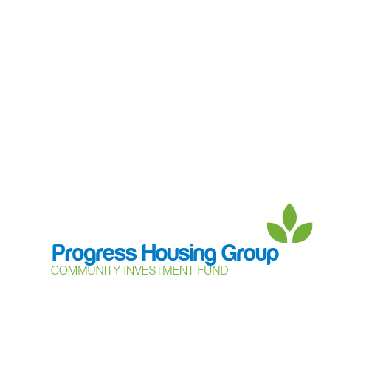

**Community Support Grant - guidance notes**

The Community Support Grant (the **Grant**) is a way for charities, community groups and local networks to apply for funding of up to £500 from Progress Housing Group’s Community Investment Fund to support community groups and projects to set up and grow.

Please read these guidance notes before completing your application form for the Community Support Grant, to make sure your project meets the criteria. Only projects meeting the criteria will be approved to receive funding.

**Application criteria:**

* Progress Housing Group owns or manages properties in the area where the project will be delivered.
* Tenants of Progress Housing Group will be able to benefit from joining the project.
* The project will have a positive effect on the community in general.
* There is a plan in place to ensure the future of the project after the initial funding has been used. The Community Investment Fund is not available to fund the same project year after year.
* The project will be run in a way that meets Progress Housing Group’s policies in relation to equality, diversity and inclusion, health and safety and safeguarding as published on its website.
* Feedback will be provided for each project using the form provided by the Customer Voice Team. This will include details of how the funds have been used and what the project has achieved.
* Groups applying for Community Support Grant funding are limited to 2 applications per financial year (April to March).
* Each application to the Community Investment Fund, by any route, will be for a different project.
* The project is making as much use as possible of other funding, including ‘in-kind funding’ to support the project.
* The group applying has a bank account in their name (we are not able to make payments to a personal bank account).

**Application process:**

Send your completed application to the Customer Voice Team either by

* email to: [community@progressgroup.org.uk](mailto:community@progressgroup.org.uk) or
* post to: Progress Housing Group, Sumner House, 21 King Street, Leyland, PR25 2LW.

All applications received will be reviewed, and a decision will be made on whether funding will be awarded or not.

Once a decision has been made, the Customer Voice Team will contact you to confirm the result of your application.

If your application is successful the Customer Voice Team will contact you to complete the next steps of the process, this does involve you providing information about the project group, including proof of bank account, public liability insurance (this may be insurance of the venue hosting the project as well as the group running the project), details of the project group, details of people within the group with authority to sign the funding grant agreement.

Before funds can be paid to the project group, a grant agreement, setting out who the funds are being paid to and how they will be used, will be signed. A copy of the grant agreement is included for your information.

If you need any help or guidance with your application, please contact the Customer Voice Team at [community@progressgroup.org.uk](mailto:community@progressgroup.org.uk) or on 0333 320 4555. We will be happy to help you.

**Data Protection Notice**

Progress Housing Group as data controller in relation to the Community Investment Fund and application process will use the personal information in your application to assess and verify your application and in doing so may share this information with: other members of the Group; its employees and other individuals involved in the assessment and monitoring of applications and awards; its advisors and other third parties including other funders or parties referred to in your application and with government or other authorities as required or permitted by law.

You are responsible for making sure that you have permission to include other people’s personal information in your application, and by making the application, you undertake to Progress Housing Group that you do have such permission from everyone identified in your application.

Application information will be stored in accordance with Progress Housing Group’s Data Retention Policy.

For more information on data protection and how Progress Housing Group deals with personal data, please see the [privacy notice](https://www.progressgroup.org.uk/about-us/corporate-responsibility/data-protection/) on our website.

The information you provide in your application will be used to process and administer your application for funding. If you would like to know about how we use your information, please go to our data protection page on the website at www.progressgroup.org.uk/D-P.

Progress Housing Group reserve the right to publish information about funding made from the Community Investment Fund through the Community Support Grant in the Group’s publications and the local media.