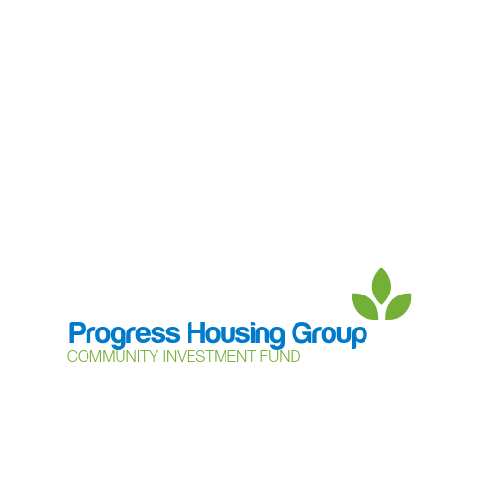

**Community Support Grant – application form**

The Community Support Grant (the **Grant**) is a way for charities, community groups and local networks to apply for funding of up to £500 from Progress Housing Group’s Community Investment Fund to support community groups and projects to set up and grow.

Before completing the application form, please refer to the Data Protection Notice and other terms of this form and the Community Support Grant application guidelines. Only projects meeting the set criteria will be approved to receive funding.

**Details of the community group, charity or network making the application**

|  |  |
| --- | --- |
| Name |  |
| Charity or Company number (if applicable) |  |

**Contact details** – who can we contact to discuss the application?

|  |  |
| --- | --- |
| Name |  |
| Phone number |  |
| E-mail address |  |
| Address |  |
| Date of application |  |
| How did you hear about the Community Support Grant? |  |

**Tell us what you would like to do!**

|  |
| --- |
| **Background details**  It would be helpful if you could include details of:   * Details of the history of the project, why the project is being suggested and/or needed. * What is the project intending to achieve, and who will benefit from it? * How long will the project last? |
| **How will the project be delivered?**  Include details of how the project will be delivered, including:   * Who is the project aimed at? * How will tenants of Progress Housing Group benefit from the project? * Details of the location of the project. |
| **Funding details**  How much funding are you applying for?  What do you need the funding for?(Please include details of what you intend to spend the funding on).  When will the funding be used? (Timescales).  Have you received funding from the Community Support Grant before? If yes, please provide the full details, including dates.  What other funding and support will you receive to help deliver the project? |
| **What do you hope will happen to the project in the longer term?**  Please include details of how you would like the project to develop in the future. |
| **Communication and consultation**  How have you communicated and consulted with the local community about the project? Please give details of the methods of communication and the response received. |
| **Feedback from the project**  We love to hear how the funding has been used to help and support local communities. Who is the best person to provide this information? Please provide their contact details. |
| If the application is successful, you will need to provide information to complete a grant agreement and payment process. Please confirm if you have the following information available for this:  **Bank account in name of the community group, charity or**  **network applying (we are not able to pay funds into a ) Yes  No**  **personal account**  **Public liability insurance Yes  No**  (This could be insurance of venue hosting the project)  **People authorised to sign a grant agreement Yes  No** |
| **Declaration**  Please confirm if you, or any person involved in the organisation, funding or management of the project, is:   * a member of Progress Housing Association’s board or any board within Progress Housing Group * a member of the Community Investment Fund Working Party * an employee of Progress Housing Association or another part of Progress Housing Group * a tenant or customer of Progress Housing Association or another part of Progress Housing Group * or a close relative or household member of such a person.   **Yes**  **No**  Please give details below if you answered “yes” |
| **Help with your application**  If you need any help or guidance with your application, please contact the Customer Voice Team at [community@progressgroup.org.uk](mailto:community@progressgroup.org.uk) or on 0333 320 4555. We will be happy to help you. |
| **Data Protection Notice**  Progress Housing Group as data controller in relation to the Community Investment Fund and application process will use the personal information in your application to assess and verify your application and in doing so may share this information with: other members of the Group; its employees and other individuals involved in the assessment and monitoring of applications and awards; its advisors and other third parties including other funders or parties referred to in your application and with government or other authorities as required or permitted by law.  You are responsible for making sure that you have permission to include other people’s personal information in your application, and by making the application, you undertake to Progress Housing Group that you do have such permission from everyone identified in your application.  Application information will be stored in accordance with Progress Housing Group’s Data Retention Policy.  For more information on data protection and how Progress Housing Group deals with personal data, please see the [privacy notice](https://www.progressgroup.org.uk/about-us/corporate-responsibility/data-protection/) on our website. |

The information you provide in your application will be used to process and administer your application for funding. If you would like to know about how we use your information, please go to our data protection page on the website at <www.progressgroup.org.uk/D-P>.

**Please return your application to the Customer Voice Team at** [**community@progressgroup.org.uk**](mailto:community@progressgroup.org.uk) **or by posting to Progress Housing Group, Sumner House, 21 King Street, Leyland, PR25 2LW.**